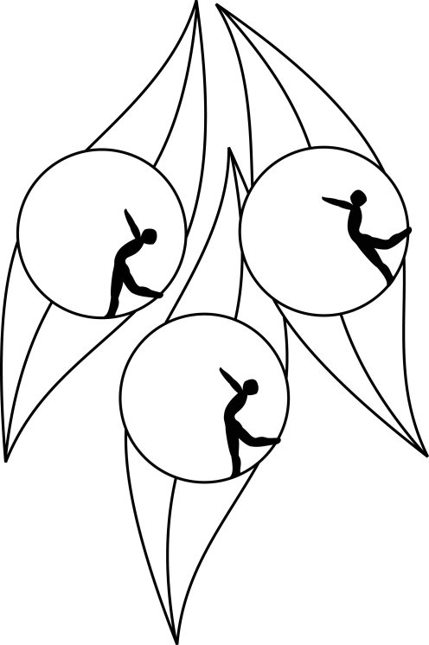
Results
South Australian Ice Skating Association Inc
Test Session

19 May 2010
IceArena, Thebarton

Congratulations to the following skaters:

Primary
Amelia Davis

Elementary 2 Figure Pattern
Alyce Skeates
Giuseppe Triulcio

